MICHAEL’S FLOORING SOLUTIONS:

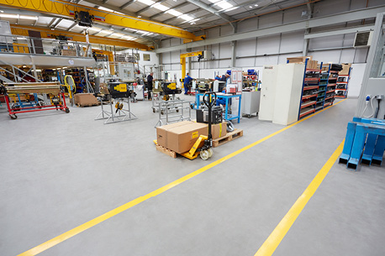  Industrial Flooring. | 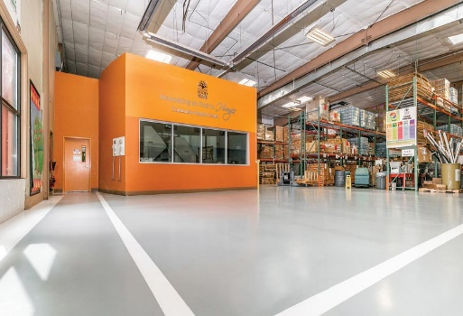  Commercial Flooring | 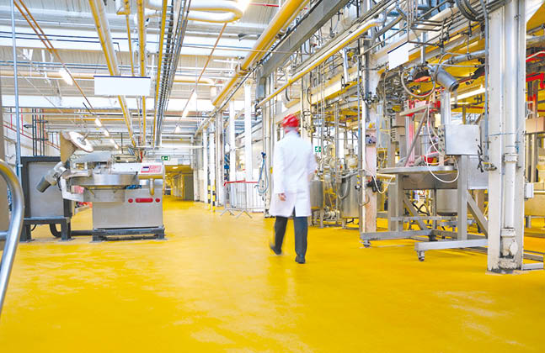  Hygienic Industrial Floor
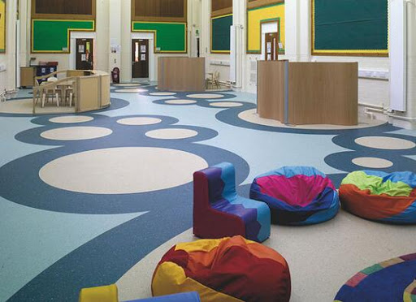  Decorative Floor | 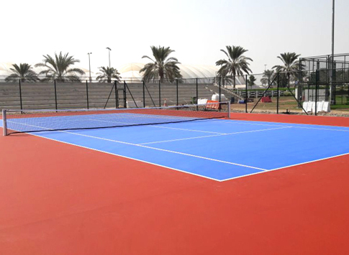  Sports Floor | 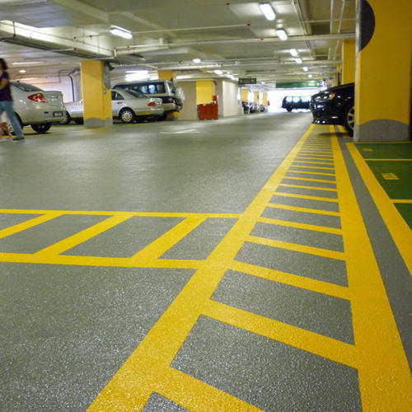  Car Parking Floor
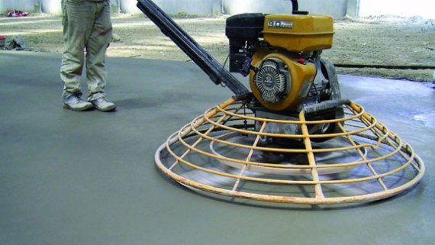  Floor Hardener | 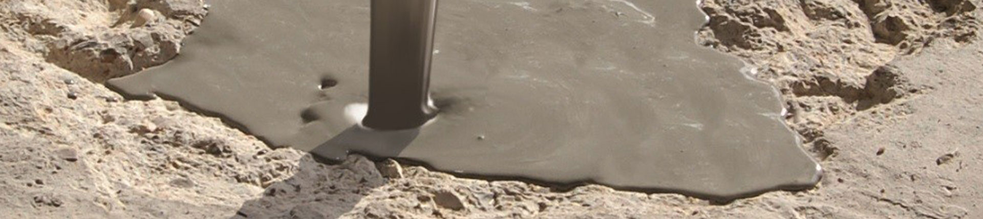  Existing Floor Repair | 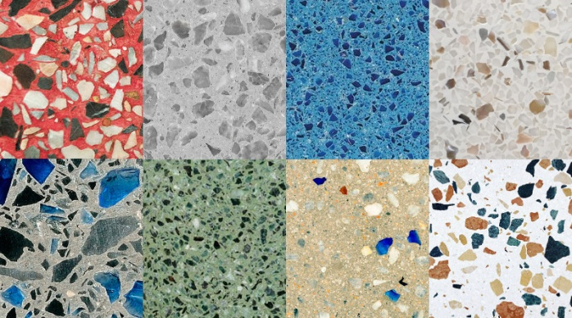  Terrazzo Floor

Sales Office: 320 DIT Road, Rampura, (1st Floor), Dhaka-1219.
Reg Office: 474/1, Boro Moghbazar, Ramna, Dhaka-1217, Bangladesh.
Phone: +8802-9340294,
Cell: +8801712281478, +8801913391032 (WhatsApp & WeChat).
Web: www.mcibd.com.bd www.michaelbd.com
Facebook: www.facebook.com/michaelcorporation

MICHAEL History:
Michael Construction & Chemical Co Ltd. is one of the leading company involve in importing, supplying and applying all type of construction chemical since 2000, having exclusive distributor of "Vandex" Switzerland. The company was incorporated as private limited company under companies’ act 1994 and duly registered with registrar of joint stock & companies and firm the Govt. of the People’s Republic of Bangladesh. From the very begging company is engaged with various construction chemical related works. We have developed professional technical / skilled teams, sufficient latest tools/ machines/ equipment, Applicators, all types of construction chemicals, completed most prominent projects including more than 500 projects in Bangladesh. We import world’s most prominent proven brand’s products. Providing green and sustainable products are our main priority.
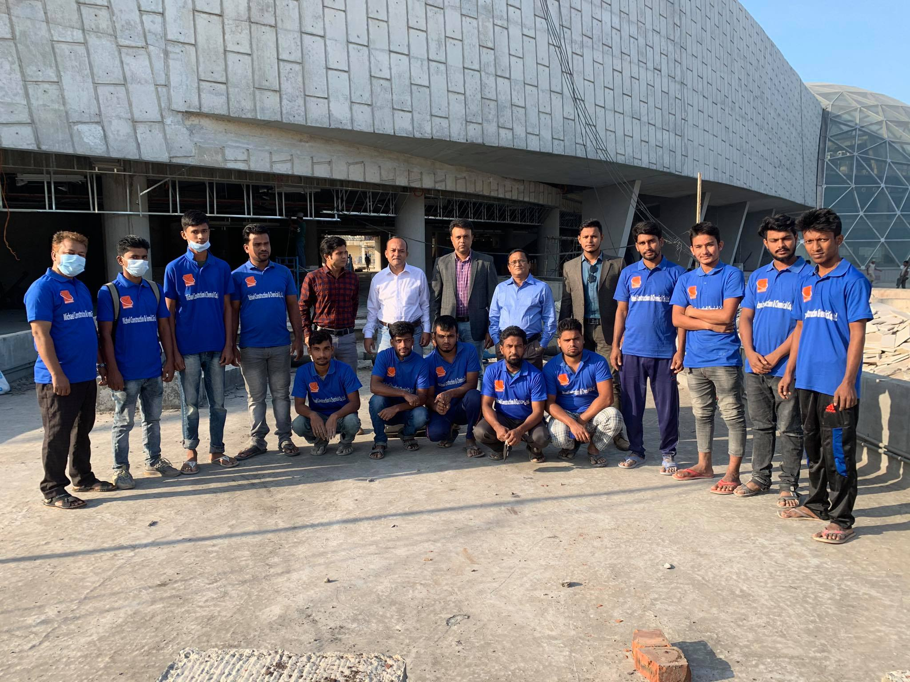
We are pioneer in supplying and installation of all types of flooring system for last 20 years. MICHAEL is a market-leader of high quality industrial and commercial resin flooring system with enhanced features and sustainable formulations in order to bring our clients the very best in performance flooring technology.

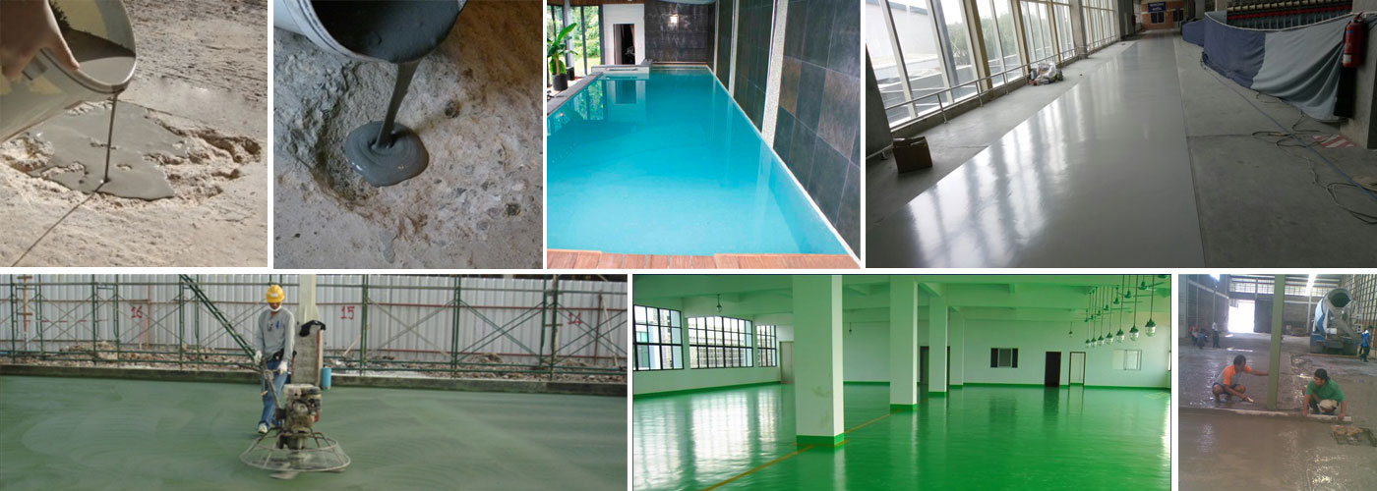

Industrial Flooring:
MICHAEL offers a wide range of industrial flooring systems whether you need chemical resistance, abrasion resistance, resistance to heavy loads, ease of maintenance or all of the above MCCCL can provide you with the perfect industrial flooring solution to match your needs.
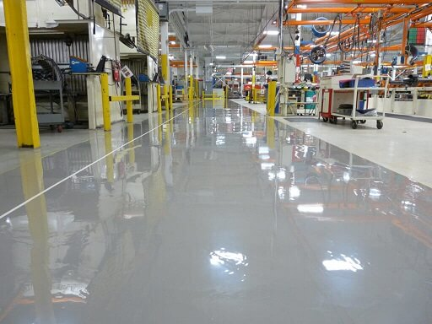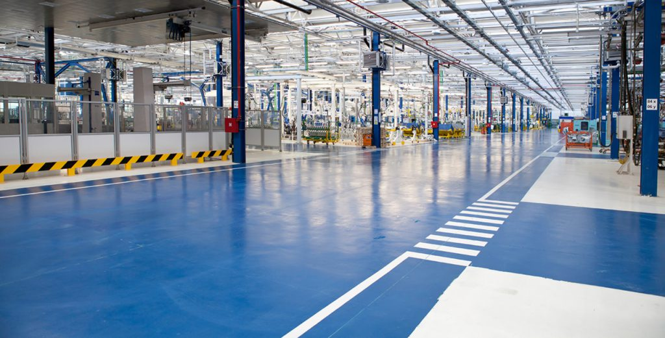
Our industrial floor coating systems are all joint-free, delivering a seamless finish with no cracks or crevices to harbor dust, dirt and bacteria. It is user-friendly to clean and maintain.

Polyurethane resin technology that gives floors exceptional resistance to aggressive chemicals, extreme mechanical and thermal shock, providing a long-term, durable flooring solution.
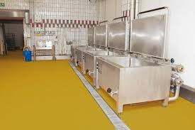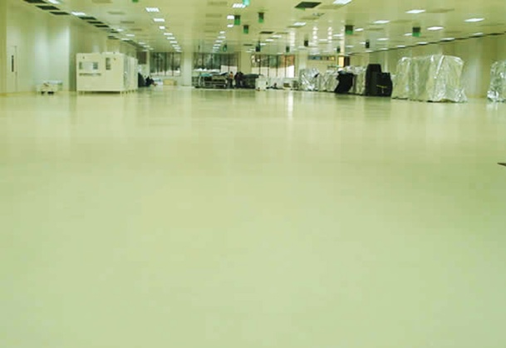

PU hygienic floors provide ideal floor finishes for applications in the food, beverage, chemical and pharmaceutical industries. They offer a uniform and seamless flooring system that creates a safe and attractive working environment. PU surfaces retain their integrity at temperatures of up to 130°C, and have been proven to meet the most stringent hygiene and cleanliness requirements where a long lasting robust floor is crucial. For employee safety, a wide range of slip resistant profiles are available.

INDUSTRIAL MANUFACTURING FACILITY FLOORS & WALLS:
MICHAEL Floors industrial toppings & coatings will protect against heavily trafficked surfaces, impacts, abrasions, oil and chemical spills, and harsh cleaning agents. Commercial manufacturing facilities have unique concrete floor and wall requirements; at MICHAEL Floors, we work with you to forecast anything your business and its employees intend to do, so we have an accurate account of what your floors need to endure. Our epoxy/PU topping & coatings ensure your concrete has long-lasting resilience with a professional aesthetic.

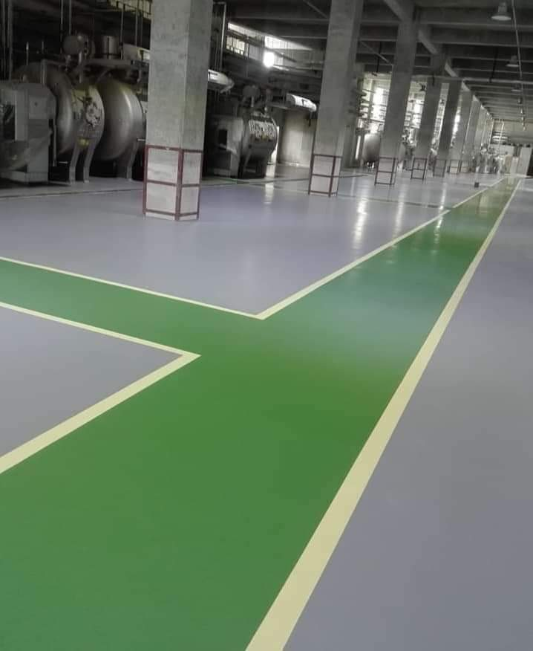
Whether your manufacturing environment be for automotive or aviation, building products and heavy equipment, electronics or various textiles and clothing, a packaging warehouses, storage or assembly line, your company’s manufacturing facility requires hard-working floors which must control and drive electrostatic discharges to ground. No matter the type of manufacturing your facility performs, we have the hard working concrete floor coatings and finishes to do the job.
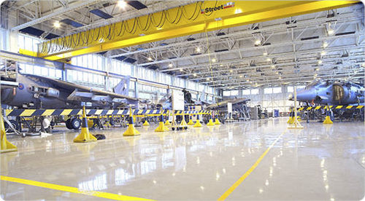
MICHAEL’s manufacturing and industrial flooring line also offer:
No waxing or polishing required | Resistance to acid, alkali, solvents and chemicals | Durable enough for heavy loads and harsh impact
Waterproof / Moisture tolerant | EPA registered antimicrobial protection for product manufacturing | Slip-resistant
Static and spark reduction | Thermal shock and steam-cleanable floors | Easy cleanable/ no dust

Commercial Floor:
MCCCL offers a variety of joint-free decorative floor coatings and toppings to create a colorful, vibrant and aesthetic surface that will create a talking point in a wide-range of commercial venues and environments.
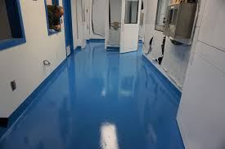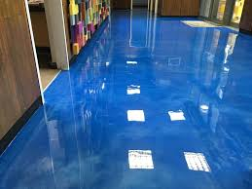
Our commercial flooring range includes high-gloss resin floor toppings, speckled quartz floor finishes and sparkling flake flooring systems, all of which have been designed for the commercial sector.

BEVERAGE & FOOD PROCESSING FLOORS & WALLS:

From food processing facilities & test kitchens to the heavy duty floor needs in food processing warehouses; wherever there is food production that requires specific, floor coatings and safety measures you can count on MICHAEL Floors.

Limiting the risks of contamination, protecting workers by installing no-slip flooring, being able to weather harsh cleaning and sanitation chemicals, avoiding possible breaks and cracks caused by thermal shock, absorbing impact, and enduring abrasion; for food processing facilities, the requirements for flooring are extensive, and if you fail to have proper coating, there is a myriad of trouble that can follow.
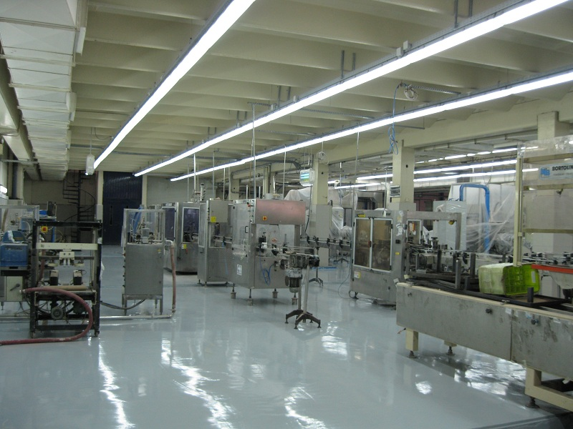
At MICHAEL Floors, our highly-skilled flooring installers have extensive knowledge and experience specific to the food processing, manufacturing and restaurant industry. It is the goal of our flooring to help your company’s food production facilities and kitchens meet their business’ goals. By using floors that can be easily cleaned, are chemically resistant, waterproof, resistant to thermal shock, and are antimicrobial, we will save your company time and money.
Special Considerations:
FDA and USDA regulations | Frequent Cleaning Schedules
Narrow Repair Times | Worker Safety / OSHA compliance

PHARMACEUTICAL FLOORS & WALLS:
Beyond being tough floors, MICHAEL Floors’ epoxy coating systems create a workplace that is conducive for a clean, healthy and safe work environment that your business and employees will take pride in. We know that Pharmaceutical facilities are rigorously cleaned and sanitized per your own policies and regulatory requirements that ensure a healthy work environment and safe product; which is why we install flooring that is easy to clean and tough enough to withstand harsh chemicals in production work, testing and heavy duty cleaning. From test kitchens and storage spaces to zero dust environments, we have the ability to meet the unique wall and flooring needs in your facilities.
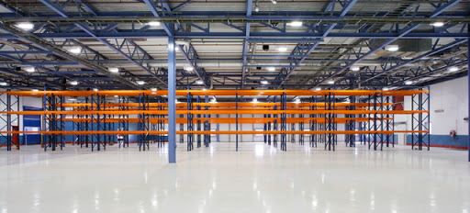
Our Pharmaceutical flooring covers the bases:
EPA-registered antimicrobial properties | Resistant to solvents, chemicals, and disinfectants | Slip-resistant
Thermal Shock Resistance | Dust Control / Waterproof | Bacteria Resistance
Moisture Vapor Transmission Resistance | Highly Cleanable / Anti-Microbial | Chemical Resistance

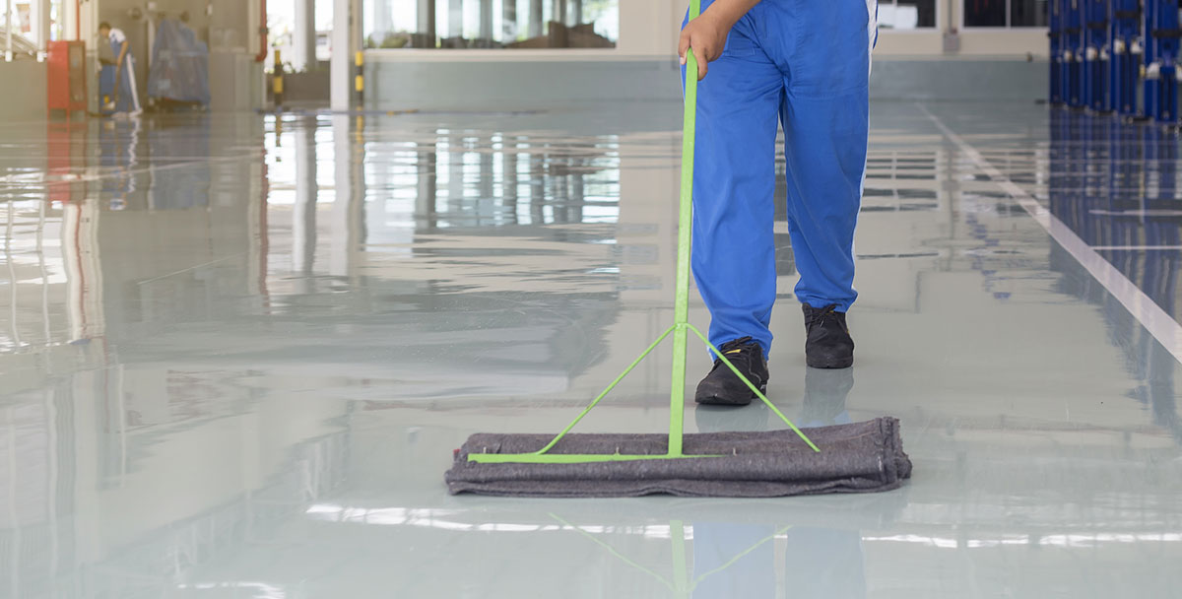

Anti-Skid Car Parking Floor:
Pioneers in the industry, we offer anti-skid PU flooring for car parking area, anti-skid epoxy flooring for car parking and anti-skid flooring services from Bangladesh.

It reduces the risk of slipping and skidding for both vehicles and pedestrians. Antiskid is highly durable, and can withstand vast amounts of traffic, weather conditions and other stress. It is also resistant to materials such as oil, fuel, and solvents, ensuring that it maintains the antiskid qualities despite accidental spillages. Our anti-skid surfacing has low toxic levels and is environmentally friendly.
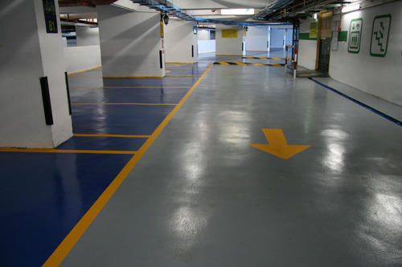
Our product is backed by the promise of fast installation time and a comprehensive warranty. It provides a convenient and effective method of protecting new developments, as well as enhancing ageing concrete structures.

Our protective car park decking, with colorful and clear delineation systems are able to be tailored to your slip resistance requirements aiding you to keep slip and trip hazards to a minimum. We can also minimize or eradicate irritating tire squeal noise.
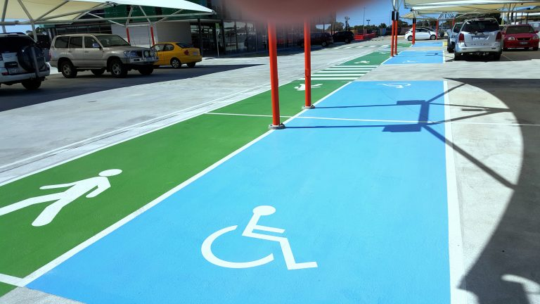

Repair and modernization of existing industrial floors:
Every day industrial floors are exposed to severe stress; they count to the most stressed parts of a building. After years of exposure to intensive mechanical stress, also the best industrial floor requires renovation. Companies and builder-owners call for long-term and economic planning, whether for new construction or for redesign and repair.
As time schedules, economic conditions, stress profiles, on-site conditions are subject to constant change, MCCCL offers various solutions for the repair of industrial floors:

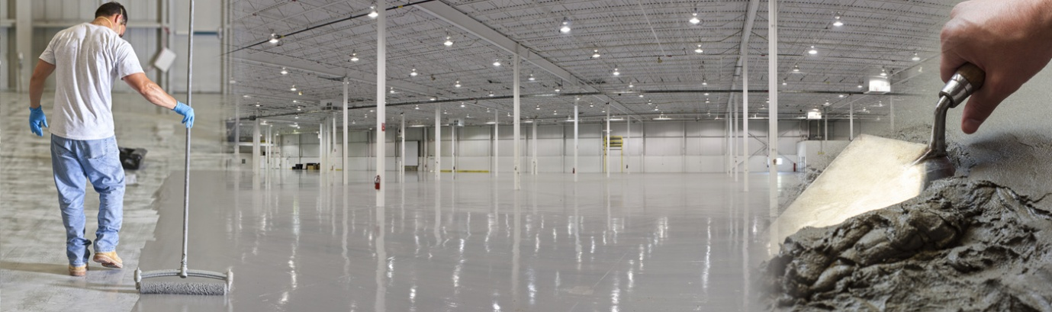
MCCCL is a leading supplier of commercial and industrial concrete repair products. For over 20 years, we have proudly serviced contractors, factories, warehouses and distribution centers for industrial, institutional and commercial customers. We carry a full range of concrete repair materials, including those specifically designed for loading, heavy traffic area or any types of industrial and commercial floor. Our floor repair products are rapid hardening, allowing you to reopen repaired areas with minimal downtime. All of our products are designed to be used by in-house maintenance personnel and come with an ironclad 100% guarantee of satisfaction.
Advantages:
Fast repair of damaged areas | Ready for foot traffic after 3 hours, ready for use after 24 hours | Wear resistance acc. to DIN 1100
Low-shrinkage | Water-resistant, suitable also in wet rooms | Durable, sustainable use
Due to its longevity, a good economic alternative

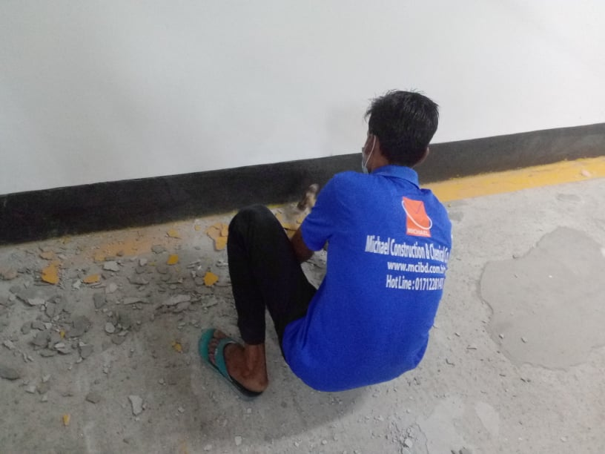

Terrazzo Floor:
If you are looking for an elegant and unique floor, look no further than terrazzo flooring. Since terrazzo floors are not very common, they add to the value of your premises as well. Although terrazzo floors can be expensive, clients do not have to worry about replacing them for a long time. This is because, when properly installed, a terrazzo floor is extremely durable. Expect these floors to last for decades, if not centuries. Due to the sealer that is placed on top, these floors are waterproof and require very little maintenance. This is why some clients choose terrazzo for their pool decks as well. Also terrazzo floors are very green.
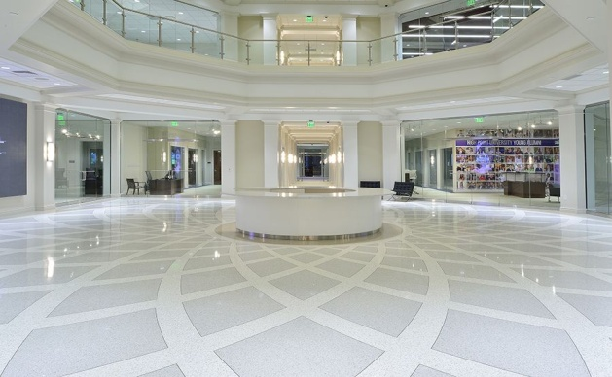

Polished Concrete Floor:
Some advantages of every MICHAEL’s Polished Concrete floor include it's unique finish, no two floors are the same. Every floor will reflect the environment it is in and will look different throughout the day making it a surface you will never get tired of. With some forward planning our clients can also customize their floor to make it their own!
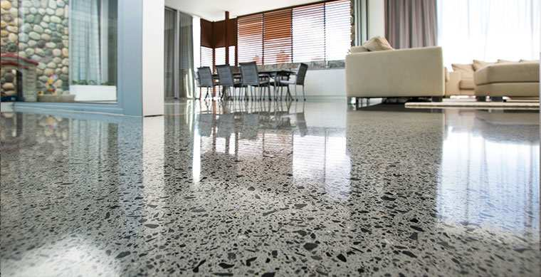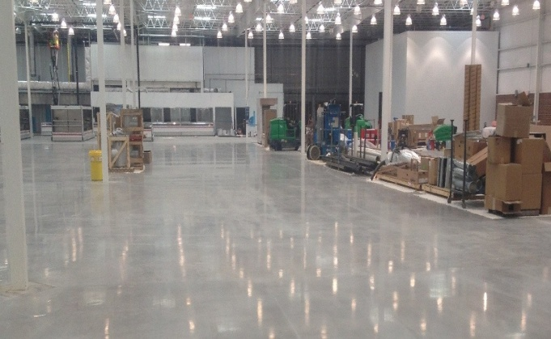

Advantages:
Incredibly hard wearing | Internal & external use | Floors, countertops & tables
Unique finish | Very low maintenance | Dust Free
Seamless | Light Reflective | Hypoallergenic
Stain Resistant | Easy cleaning | Scratch Resistant

Parking Accessories:
We also provide all parking accessories like Convex Mirror, Rubber Wheel Stopper, Column Corner Guard, Road Stud, Rubber speed breaker, Bollard, Arm Barrier etc.

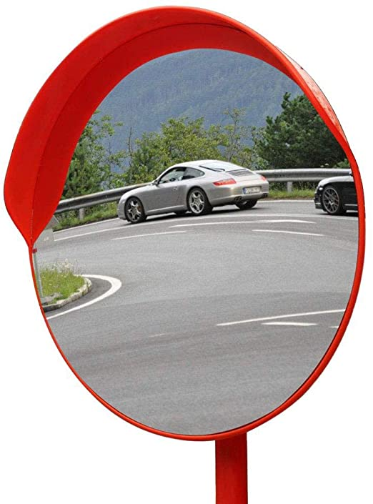  Convex Mirrors | 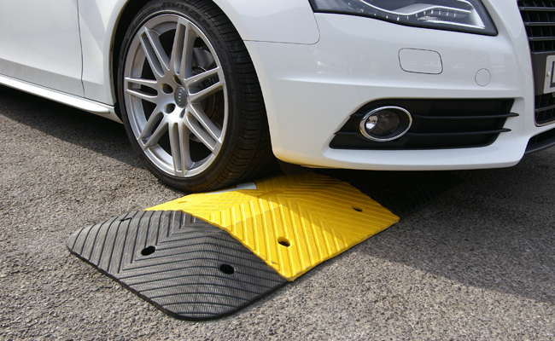  Speed Humps/Bumps
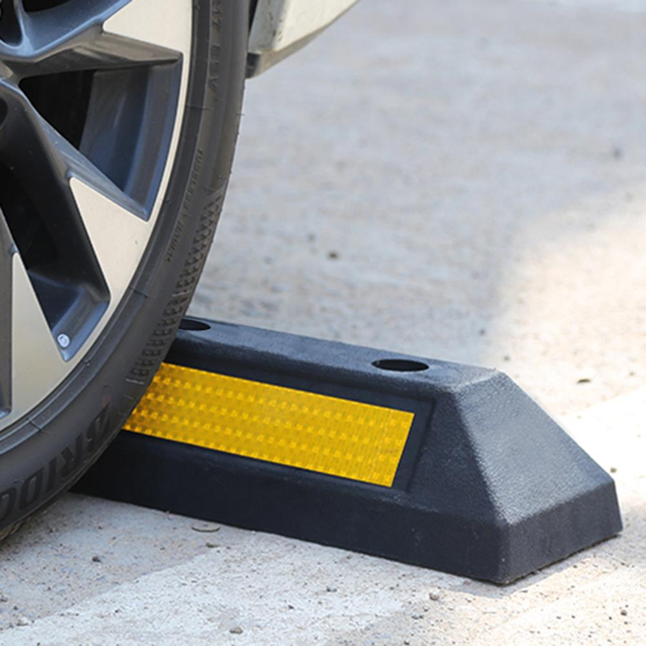  Wheel Barriers | 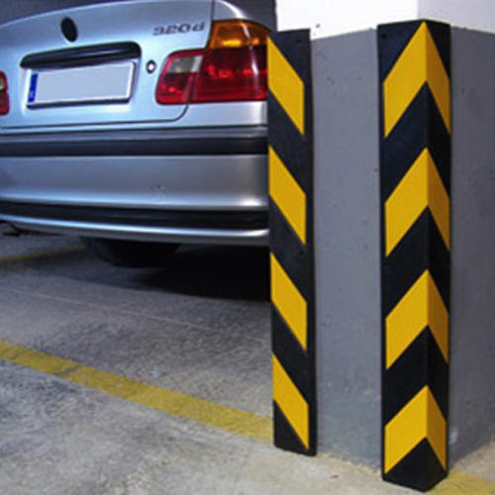  Column Corner Safety Guards

Every job we preform is unique and done with the utmost care and technical support. Contact Michael Construction & Chemical Co, Ltd. when you’re ready to talk about getting the job done, and we’ll go over your specific requirements and specifications.
Reach out online or call us any time at 01712-281478

